**Problem Statement**

**Product Dissection for top leading Platforms**

Welcome to this case study on dissecting and designing products for top leading platforms. In this case study, you will delve into the intriguing world of schema design for a prominent platform of your choice. Your task is to choose a top leading platform, research its features, and meticulously craft a schema design that encapsulates the essence of its functionality. By focusing on key entities, attributes, and relationships, you will gain invaluable insights into how data architecture drives the platform's effectiveness.

**Step 1: Choose a Leading Platform**

Select a leading platform of your choice, which could span various domains such as social media, e-commerce, finance, or any other industry. This choice will form the foundation of your exploration into its schema design.

**Step 2: Research:**

Thoroughly research the platform you have selected. Investigate its core features, functionalities, and user interactions. Identify the top features that define its user experience and contribute significantly to its popularity.

**Step 3: Product Dissection and Real World Problems solved by the platform**

In this step, you will meticulously analyze the platform's standout features and how they provide innovative solutions to real-world challenges. By identifying key functionalities that resonate with users, you'll unravel how the platform effectively addresses problems and enhances user experiences. This dissection will serve as the foundation for understanding how the schema design aligns with the platform's core objectives.

**Step 4: Case Study on the real world problems and approach to solving them**

In this pivotal step, you will expand on the real-world challenges uncovered in Step 3 through a comprehensive case study. Delve into specific instances where users encountered difficulties and showcase how the platform's unique features provided effective solutions. By dissecting the approach taken by the platform to overcome these challenges, you'll gain a deeper appreciation for the platform's user-centric design philosophy and how it shapes the schema design.

**Step 5: Schema Design Based on Top Features**

Based on the features you have identified, craft a schema design that reflects the platform's data structure. Focus on the key entities, attributes, and relationships that underpin the chosen features. Your schema should capture the essence of how the platform organises and utilises its data.

**Step 6: Rationale Behind the Design**

While creating the schema design, consider the rationale behind the platform's choices. Reflect on why certain entities and relationships were chosen and how they align with the platform's goals. This will help you understand the strategic decisions driving the schema's architecture.

**Step 7: Create an ER Diagram**

Utilize tools like the Miro platform or similar applications to create an illustrative Entity-Relationship (ER) diagram. This diagram should vividly depict the entities, attributes, and relationships present within your schema design. The ER diagram will serve as a visual representation of your insights.

**Step 8: Presentation of Findings**

Present your findings in a clear and concise manner. Showcase your understanding of how the schema design impacts the platform's functionality and user experience. Explain how your chosen features are integrated into the schema and how the schema's structure supports the platform's objectives.

**Task Details:**

1. **Answer Submission:** Your submission should include well-structured solutions for all provided questions related to product schema designs.
2. **Video Creation:** Create an informative and engaging video where you thoroughly explain the Case Study.
3. **Depth and Clarity:** Ensure your solutions are detailed and showcase your understanding of product schema design principles. Similarly, in the video, provide clear explanations that are easy to understand for a wide audience.
4. **Creativity Encouraged:** You are welcome to utilise visuals, diagrams, or creative elements to enhance the clarity and impact of your explanations.

**Note:**

1. Duplicate this document and proceed to write your solutions and prepare your video.
2. Include the video link in this document before final submission.

Best of luck in completing this project and showcasing your prowess in dissecting and designing product schema for leading platforms!

 Linkedin

**Product Dissection for Linkedin**

### **Company Overview:**

LinkedIn is a professional social networking platform that was founded in December 2002 and launched in May 2003. The company's primary mission is to connect the world's professionals to make them more productive and successful. LinkedIn is widely regarded as the leading platform for professional networking and has transformed the way people connect, find jobs, and share industry insights.

#### **Problem 1: Disconnect in Digital Relationships**

**Real-World Challenge:**

In an increasingly digital world, maintaining genuine and meaningful professional relationships can be challenging. Digital interactions often lack the depth and authenticity found in face-to-face connections, leading to a disconnect in digital relationships. Many professionals struggle to convey their personalities, emotions, and professional identities effectively in the digital realm.

**LinkedIn's Solution:**

LinkedIn addresses the challenge of disconnect in digital relationships by providing a platform that allows professionals to showcase their complete professional identity. Here's how:

**Rich User Profiles:** LinkedIn users can create detailed professional profiles that include their work history, skills, education, endorsements, and recommendations. These profiles serve as digital resumes and provide a holistic view of a professional's background and expertise.

**Media Sharing:** Users can enhance their profiles with media files, including documents, images, videos, and presentations. This feature allows professionals to showcase their work, portfolio, and projects, adding a personal touch to their profiles.

**Professional Insights:** The platform encourages users to share articles, posts, and updates about their industry, experiences, and interests. This content sharing enables users to express their thoughts, insights, and perspectives, fostering meaningful interactions.

**Recommendations and Endorsements:** Users can request recommendations and endorsements from colleagues and connections. These serve as endorsements of a user's skills and professionalism, adding credibility to their profiles.

**Connections and Networking:** LinkedIn's core feature is connecting with other professionals. Users can connect with colleagues, acquaintances, industry peers, and potential employers. These connections can lead to meaningful interactions and opportunities.

**Messaging and Conversations:** LinkedIn's messaging system allows users to have one-on-one conversations with their connections. It provides a platform for personalized communication, networking, and professional discussions.

By combining these features, LinkedIn enables professionals to bridge the gap in digital relationships. Users can express their professional identities, share their experiences, connect with like-minded professionals, and engage in meaningful conversations. This comprehensive approach empowers users to establish and nurture genuine professional relationships, addressing the challenge of disconnect in digital interactions.

#### **Problem 2: Information Overload**

**Real-World Challenge:**

In the professional world, individuals are bombarded with an overwhelming amount of information from various sources, including news, articles, updates, and job postings. This information overload can make it challenging to find relevant and valuable content and opportunities.

**LinkedIn's Solution:**

LinkedIn addresses information overload by offering features like customized feeds, content recommendations, followed hashtags, job recommendations, advanced search, and email digests. These tools help users find and prioritize the most relevant content and opportunities, streamlining their professional experiences.

#### **Problem 3: Finding a Niche for Creativity**

**Real-World Challenge:** Many individuals aspire to pursue creative endeavors, but finding a platform to showcase and monetize their talents can be daunting.

**LinkedIn's Solution:**

LinkedIn empowers creative professionals to exhibit their skills, expertise, and creative work through features like LinkedIn Articles, Project Showcases, and Professional Groups. This provides a platform for individuals to display their creativity, gain recognition, and connect with like-minded professionals. Creative individuals on LinkedIn can turn their passion into a professional niche, addressing the challenge of finding a platform for creativity and fostering personal and career growth.professional niche, addressing the challenge of finding a platform for creativity and fostering personal and career growth.

#### **Problem 4: Limited Personal Branding**

Real-World Challenge: Establishing a unique online identity can be challenging, as traditional text-based platforms often limit personal branding.

**LinkedIn's Solution:**

LinkedIn allows users to create comprehensive professional profiles that include a profile picture, professional headline, summary, featured content, and endorsements. This space enables users to showcase their skills, accomplishments, and personal brand in a professional context, addressing the challenge of limited personal branding on traditional platforms.

**Conclusion:**

LinkedIn's commitment to professional networking and personal branding is evident in its user-centric approach. By offering a platform for users to build and promote their professional identities, LinkedIn has successfully tackled the challenge of limited personal branding, helping individuals stand out in the professional world. This case study highlights how LinkedIn has become a leader in professional networking and personal branding, shaping the way professionals connect and build their careers online.

### **Top Features of Linkedin:**

LinkedIn is a business-oriented social media platform with over 740 million members. Some of its top features include:

* **Showcase page**: A key feature for businesses with multiple target audiences
* **Name pronunciation**: Users can record an audio clip of how to pronounce their name and add it to their profile
* **Save posts**: Users can save job searches, posts, and LinkedIn learning programs
* **Private messaging**: Users can access private messaging and groups
* **Alumni search**: Users can search for alumni
* **Keywords**: Users can use keywords
* **Activity**: Sharing relevant content with your network
* **Hashtag**: LinkedIn hashtags are **terms with a "#" symbol before keywords**. They are used in posts, comments, and add descriptions to increase reach. Hashtags can also help people connect with like-minded people on the platform.

### **Schema Description:**

The schema for Linkedin involves multiple entities that represent different aspects of the platform. These entities include Profile, Posts, Comments, Likes, Followers, Hashtags, and more. Each entity has specific attributes that describe its properties and relationships with other entities.

**Profile Entity:**

Users are central to LinkedIn. The user entity contains information about each professional user:

* UserID (Primary Key): A unique identifier for each user.
* User_name: The first name of the user.
* Full_Name: The Full name of the user.
* Headline: A professional headline summarising the user's expertise or current role.
* Email: The user's email address for professional communication.
* Summary: A brief professional summary or bio.
* Skills: A list of skills associated with the user's professional profile.
* Connection_Count: The count of professional connections.
* Profile_Date: The date when the user joined LinkedIn.

**Post Entity:**

Posts allow users to share professional updates and insights:

* PostID (Primary Key): A unique identifier for each post.
* UserID (Foreign Key referencing User Entity): The user who created the post.
* Content: The text or media content shared in the post.
* Image_URL: The URL of any image or media attached to the post.
* Post_Date: The date when the post was created.

**Comment Entity:**

Comments enable users to engage in discussions on posts:

* CommentID (Primary Key): A unique identifier for each comment.
* PostID (Foreign Key referencing Post Entity): The post being commented on.
* UserID (Foreign Key referencing User Entity): The user who posted the comment.
* Text: The text content of the comment.
* Comment_Date: The date when the comment was posted.

**Like Entity:**

Likes represent user appreciation for posts:

* LikeID (Primary Key): A unique identifier for each like.
* PostID (Foreign Key referencing Post Entity): The post being liked.
* UserID (Foreign Key referencing User Entity): The user who liked the post.
* Like_Date: The date when the like was registered.

**Follower Entity:**

Followers establish professional connections between users:

* FollowerID (Primary Key): A unique identifier for each follower relationship.
* FollowingUserID (Foreign Key referencing User Entity): The user who is being followed.
* FollowerUserID (Foreign Key referencing User Entity): The user who is following.
* Follow_Date: The date when the following relationship was initiated.

**Hashtag Entity:**

Hashtags categorise and group content based on professional topics:

* HashtagID (Primary Key): A unique identifier for each hashtag.
* Tag: The actual text of the hashtag.

**PostHashtag Entity:**

Associates posts with hashtags:

* PostHashtagID (Primary Key): A unique identifier for each association.
* PostID (Foreign Key referencing Post Entity): The post associated with the hashtag.
* HashtagID (Foreign Key referencing Hashtag Entity): The hashtag associated with the post.

**Relationships are:**

**1.Users create Posts:**

* Each user on LinkedIn can create multiple posts.
* Each post is created by one user.

**2.Users comment on Posts:**

* Users on LinkedIn can comment on multiple posts.
* Each post can have multiple comments.
* Each comment is made by one user.

**3.Users like Posts:**

* LinkedIn users can like multiple posts.
* Each post can have multiple likes.
* Each like is registered by one user.

**4.Users connect with other Users:**

LinkedIn users can connect with multiple other users.

* Each user can be connected with multiple users.
* The connection relationship is reciprocal – if User A connects with User B, it implies that User B is also connected with User A.

**5.Users follow Company Pages:**

* LinkedIn users can follow multiple company pages.
* Each company page can be followed by multiple users.

**6.Users endorse Skills on Profiles:**

* LinkedIn users can endorse multiple skills on the profiles of other users.
* Each skill on a user's profile can be endorsed by multiple users.

**7.Users join and participate in Groups:**

* LinkedIn users can join multiple groups.
* Each group can have multiple members.
* Users can participate in discussions within these groups.

**8.Users send and receive Messages:**

* LinkedIn users can send messages to multiple other users.
* Each message is sent by one user and received by another user.

**9.Users post and share Articles:**

* LinkedIn users can post and share multiple articles.
* Each article is posted by one user.

**10.Users recommend and get Recommendations:**

* LinkedIn users can recommend multiple skills on the profiles of other users.
* Each skill on a user's profile can be recommended by multiple users.

### **ER Diagram:**

Let's construct an ER diagram that vividly portrays the relationships and attributes of the entities within the Linkedin schema. This ER diagram will serve as a visual representation, shedding light on the pivotal components of the Linkedin data model. By employing this diagram, you'll gain a clearer grasp of the intricate interactions and connections that define the platform's dynamics.

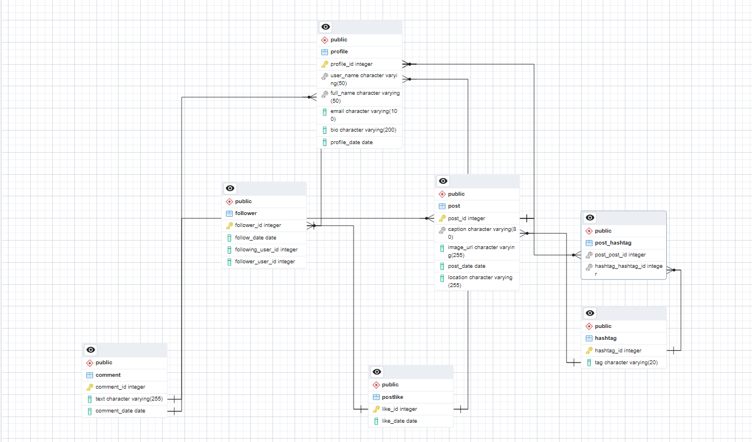

### **Conclusion**

In this case study, we delved into the design of Linkedin schema and Entity-Relationship diagram. Linkedin has revolutionised the way people share and engage with visual content, fostering connections and creative expression. The platform's intricate data model, consisting of entities like profiles, posts, comments, likes, followers, hashtags, and associations, forms the foundation for its seamless functionality. By understanding this schema, we gain insight into how Linkedin effectively manages the complexities of profiles interactions and content sharing, contributing to its widespread popularity and continued growth in the world of social media.

Video Link –

https://drive.google.com/file/d/1yC4WZlHR03LRQC_9jOMiL6WrDlCUXQSl/view?usp=sharing